Tab 1

Automated Network Request Management Using Servicenow(ANRM)

Project Documentation

Project Title

Automated Network Request Management (ANRM) Using ServiceNow

Objective

The objective of the Automated Network Request Management (ANRM) project is to automate the process of handling network-related service requests within an organization. The application enables users to submit network requests, allows authorized approvers to review and approve or reject requests, sends automated email notifications, provides reporting capabilities, and supports self-service request status checking.

Milestone 1: Project Planning and Environment Setup

Objective

To prepare the ServiceNow development environment and create the foundation for the ANRM application.

Step 1: Create Personal Developer Instance (PDI)

Visit developer.servicenow.com.

Sign in or create a developer account.

Request a Personal Developer Instance.

Wait for instance activation.

Login using admin credentials.
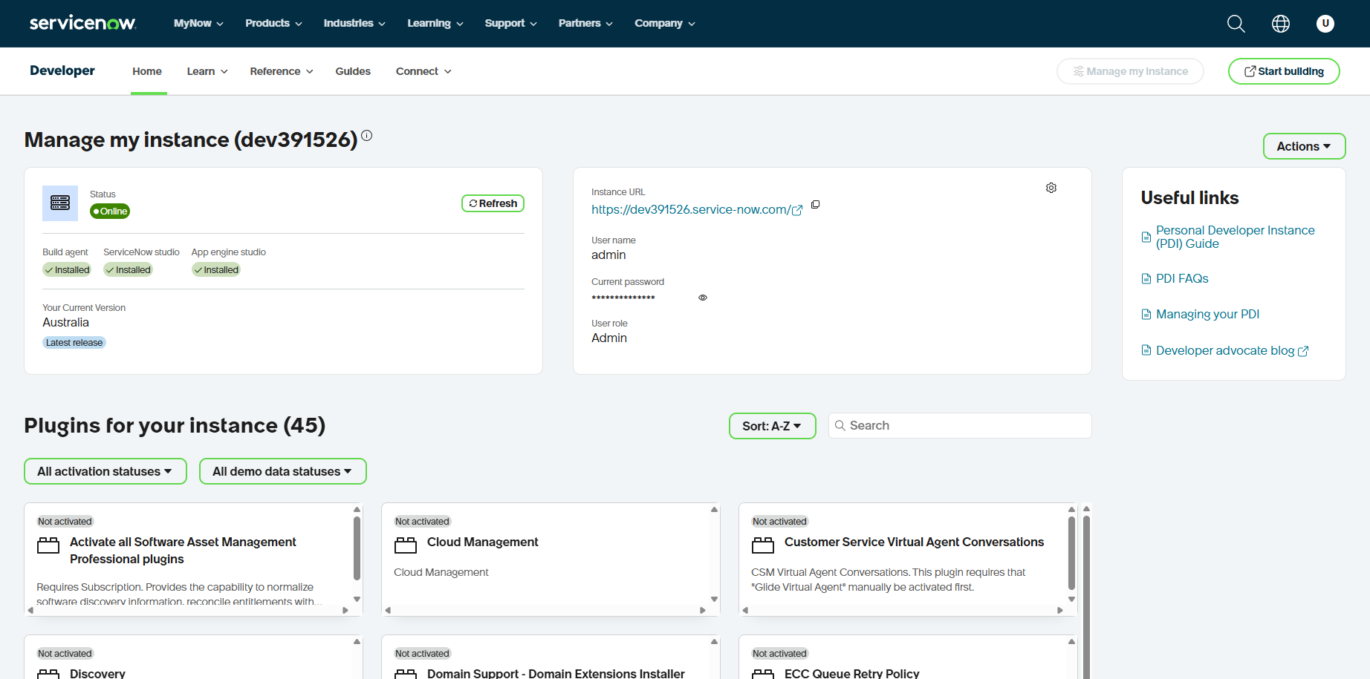
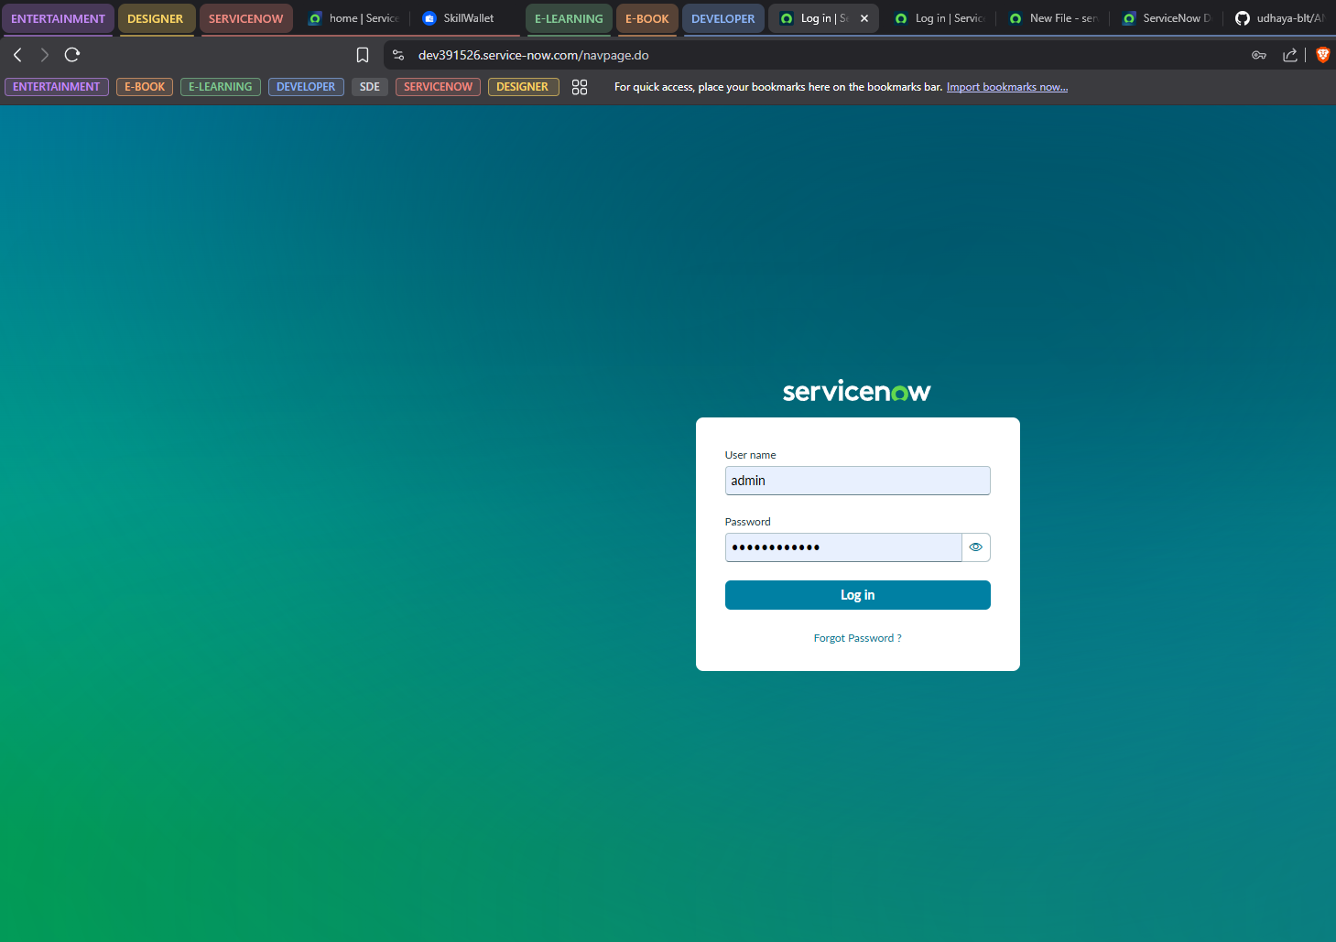

Step 2: Create Scoped Application

Navigation:

System Applications → Studio

Open Studio.

Select Create Application.

Enter:

Application Name:
Automated Network Request Management

Click Create.
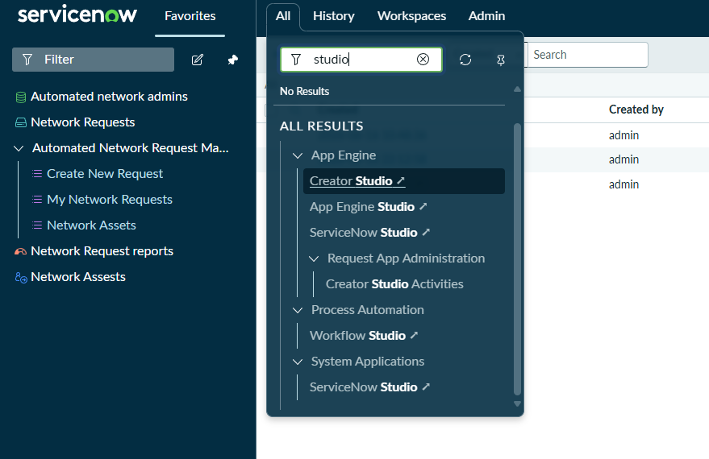

Learning Outcomes

• Understood ServiceNow architecture.
• Created a scoped application.
• Configured development environment.
• Learned Studio basics.

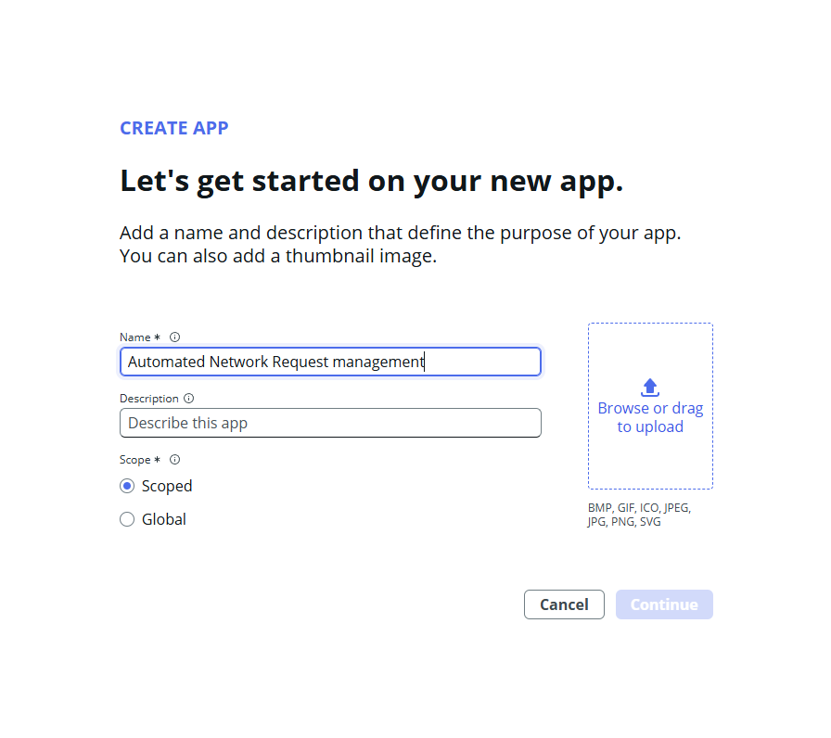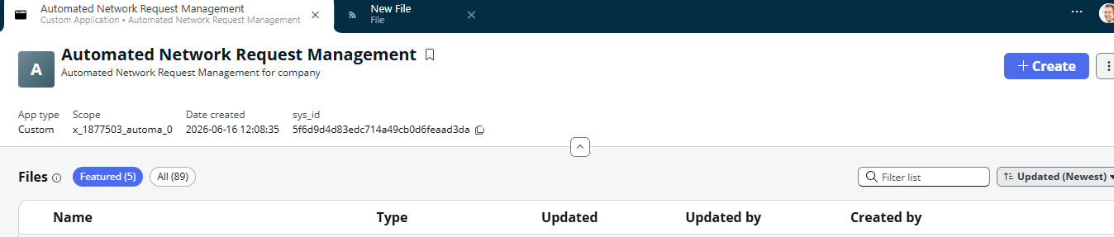

Learning Outcomes
• Understood ServiceNow architecture.
• Created a scoped application.
• Configured development environment.
• Learned Studio basics.

Milestone 2: Data Model Design

Objective
Design tables and relationships for network request management.

Step 1: Create Network Request Table
Navigation:
Studio → Create Application File → Table
Table Name:
Network Request
Parent Table:
Task
Fields:
• Request Type
• Requested For
• Department
• Justification
• Approval Status
• Network Zone
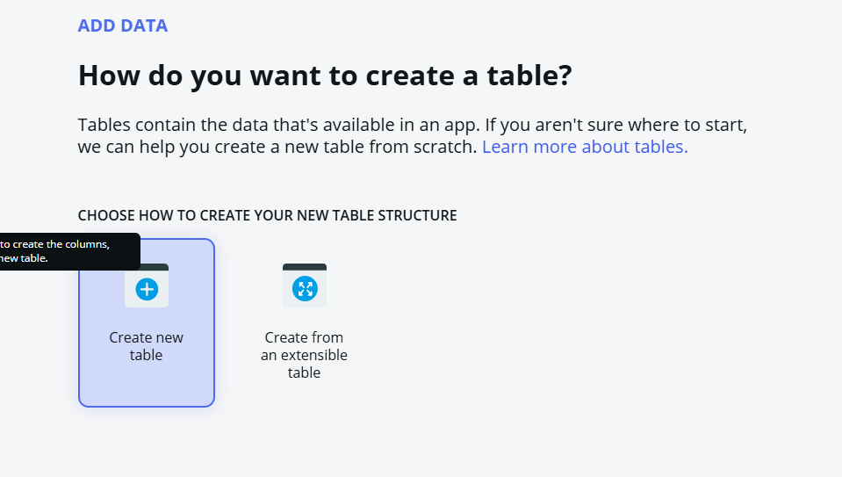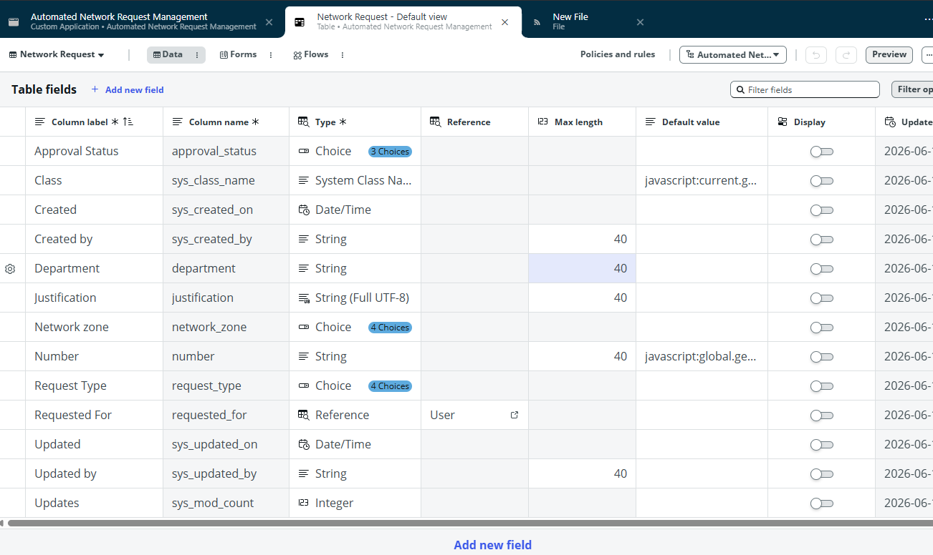

Step 2: Create Network Asset Table
Create another custom table.
Fields:
• Asset Tag
• IP Address
• Asset Type
• Status
• Assigned Request
Reference:
Assigned Request → Network Request
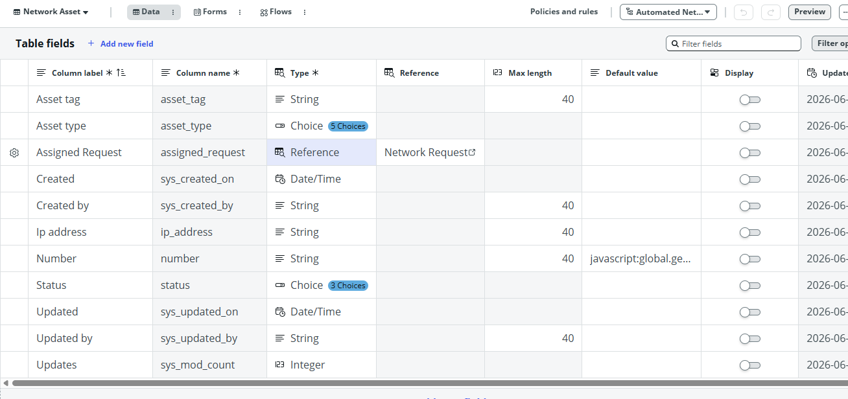

Step 3: Create Application Modules
Modules created:
• Network Requests
• Create Network Request
• Network Assets
• My Network Requests
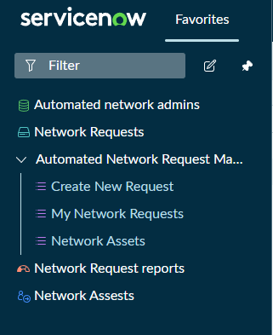

Learning Outcomes
• Created custom tables.
• Extended Task table.
• Created relationships.
• Built navigation modules.

Milestone 3: Business Logic and Security

Objective
Implement automation and access control.

Step 1: Configure Form Layout
Navigation:
Open Network Request Form
Right Click
Configure
Form Layout
Arrange fields logically.
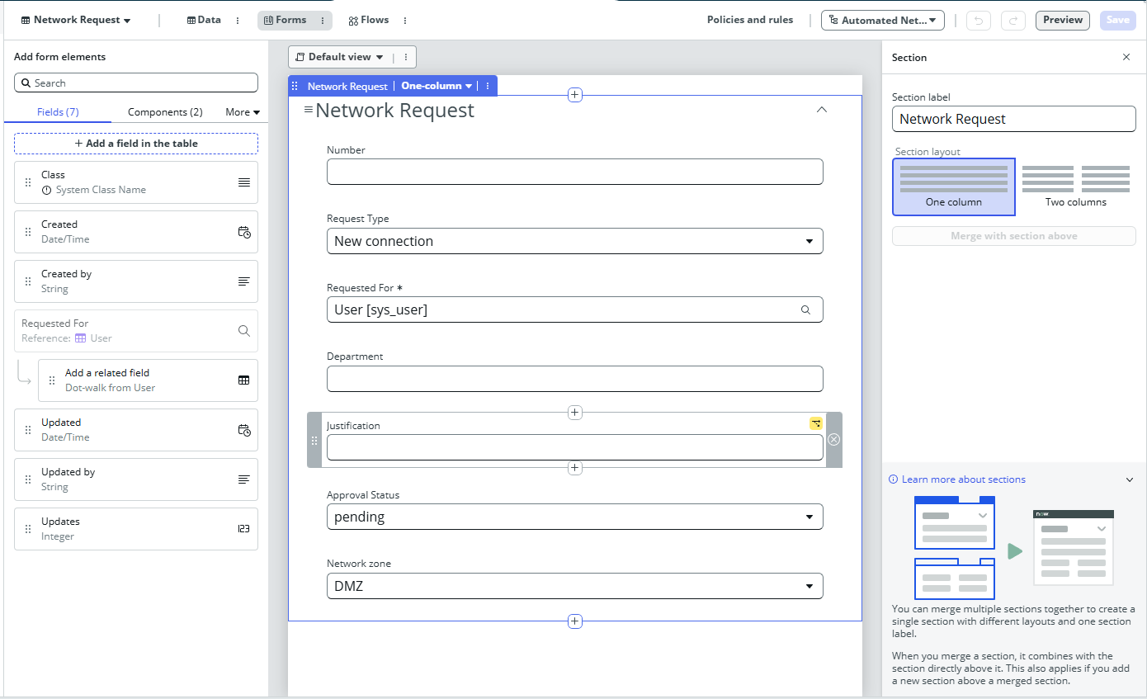

Step 2: Create UI Policy
Purpose:
Make Justification mandatory when Approval Status is Rejected.
Navigation:
sys_ui_policy.list
Create UI Policy.
Condition:
Approval Status = Rejected.
Add UI Policy Action:
Justification Mandatory = True.
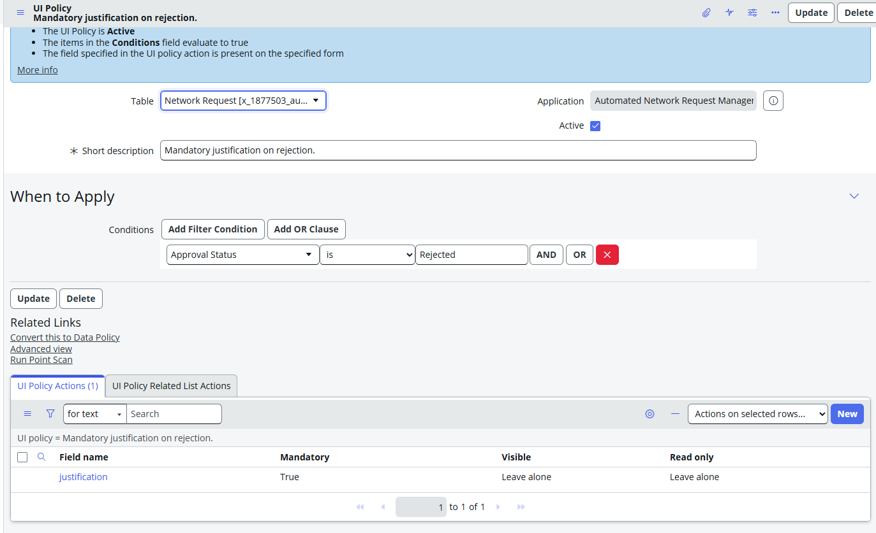
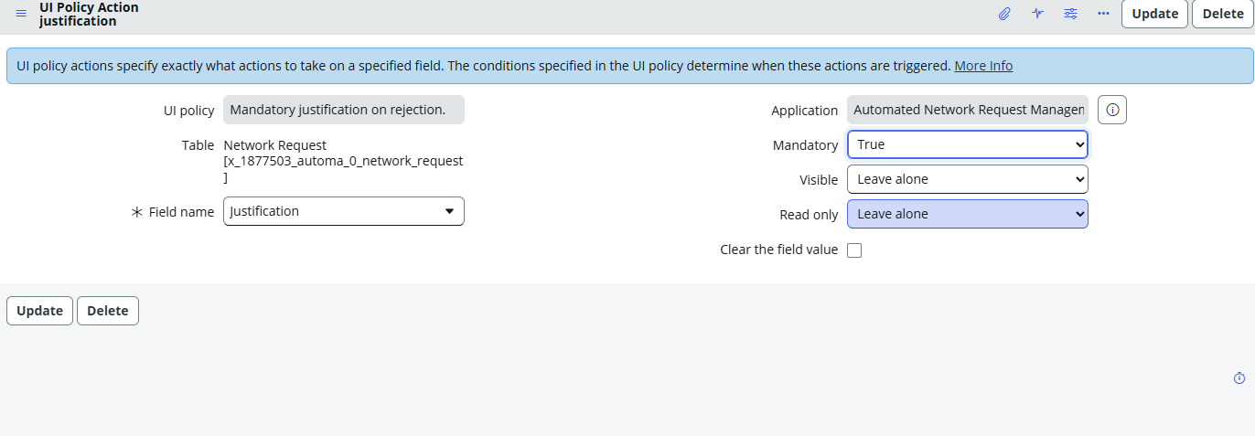

Step 3: Create Custom Role
Navigation:
sys_user_role.list
Role:
x_company_anrm.network_approver
Assign role to test approver.
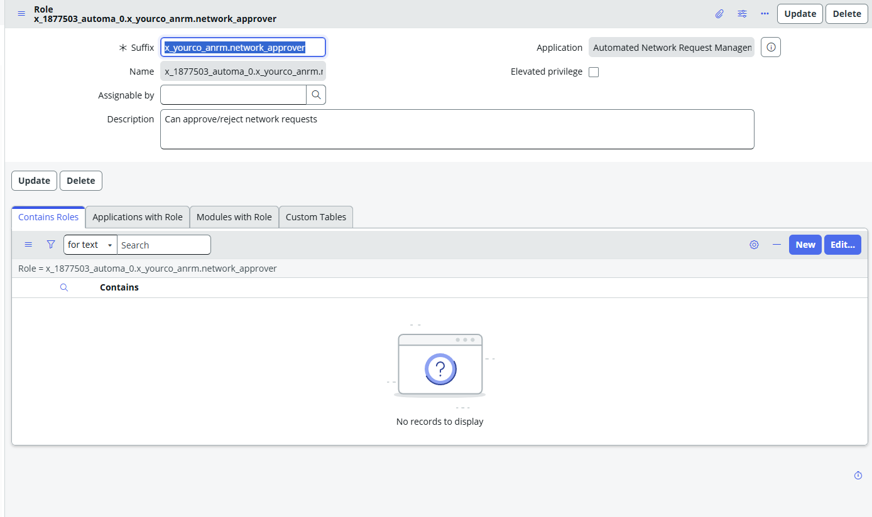

Step 4: Create ACL
Create two ACLs.
Write ACL:
Only approvers can update Approval Status.
Read ACL:
All users can view Approval Status.
Screenshot Placeholder
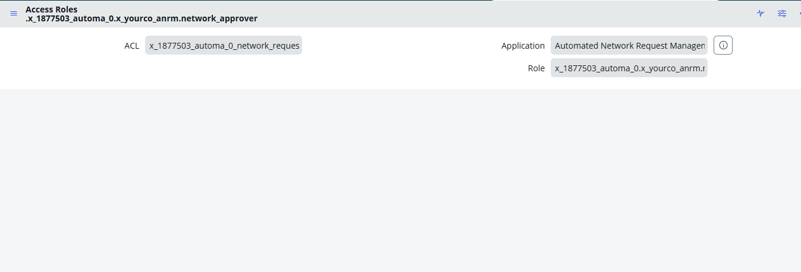

Step 5: Business Rule 1
Purpose:
Automatically set Approval Status to Pending during record creation.
Result:

Every new request starts with Pending status.
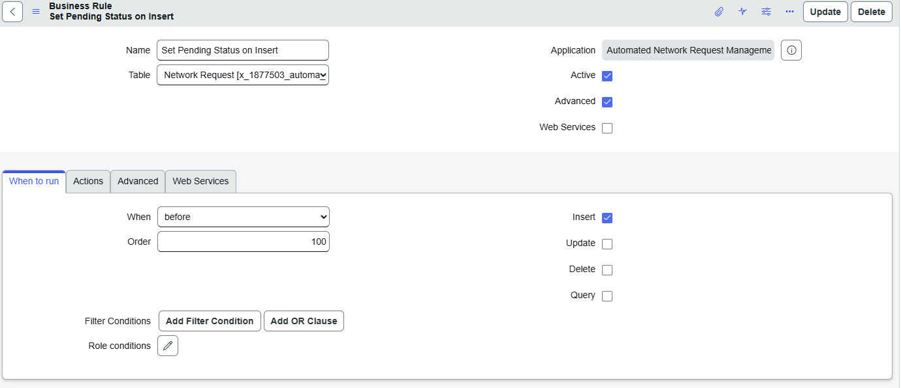
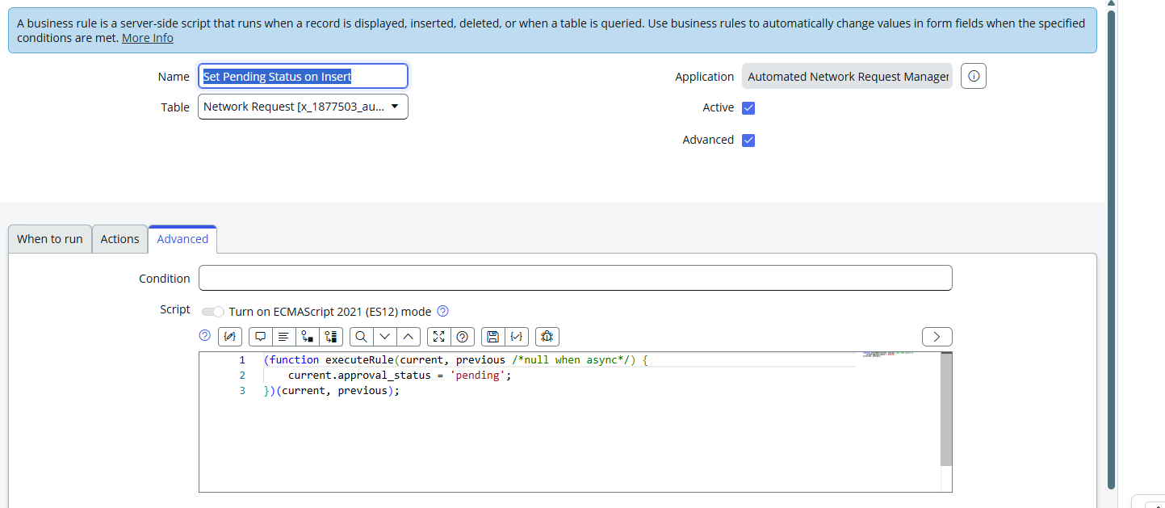

Step 6: Business Rule 2
Purpose:
Synchronize Task State with Approval Status.
Approved:
State = Work in Progress.
Rejected:
State = Closed Incomplete.
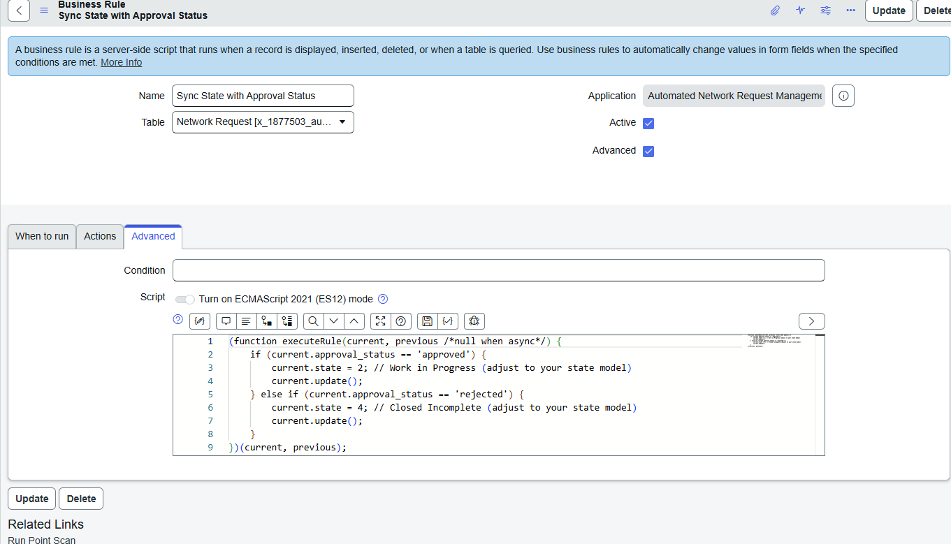

Learning Outcomes
• Implemented UI Policies.
• Created Business Rules.
• Applied ACL security.
• Created custom roles.

Milestone 4: Notification and Reporting

Objective
Improve communication and monitoring.

Step 1: Email Notification
Notification 1:
New Network Request Submitted.
Recipient:
Approver.
Contents:
Request Number
Request Type
Department
Justification

Step 2: Status Update Notification
Recipient:
Requested For
Subject:
Your request status has changed.
Include:
Request Number
Approval Status
Network Zone
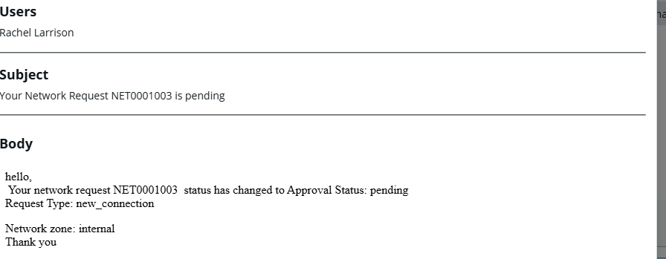

Step 3: Verify Emails
Navigation:
sys_email.list
Verify generated emails.
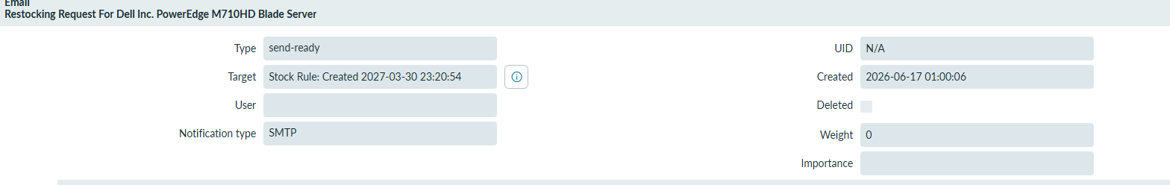

Step 4: Configure List Layout
Columns:
Number
Request Type
Requested For
Department
Approval Status
Network Zone
Created Date

Step 5: Create Report
Navigation:
Reports
Create New
Type:
Bar Chart
Group By:
Request Type
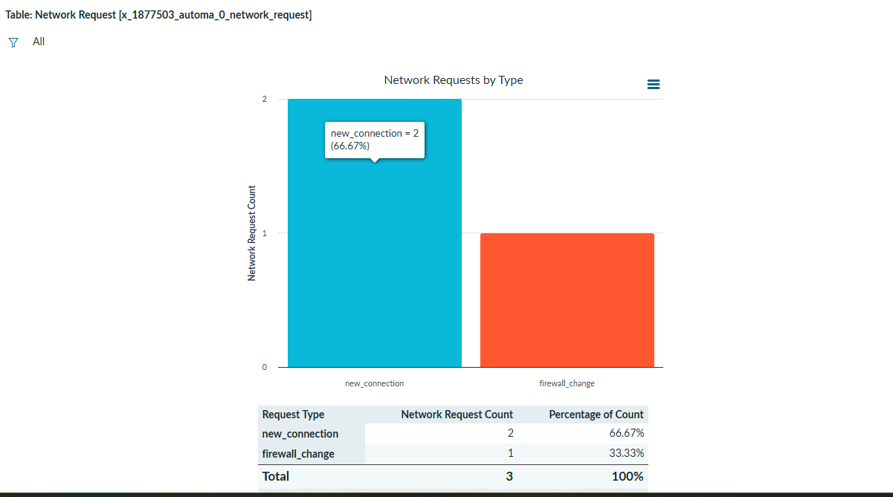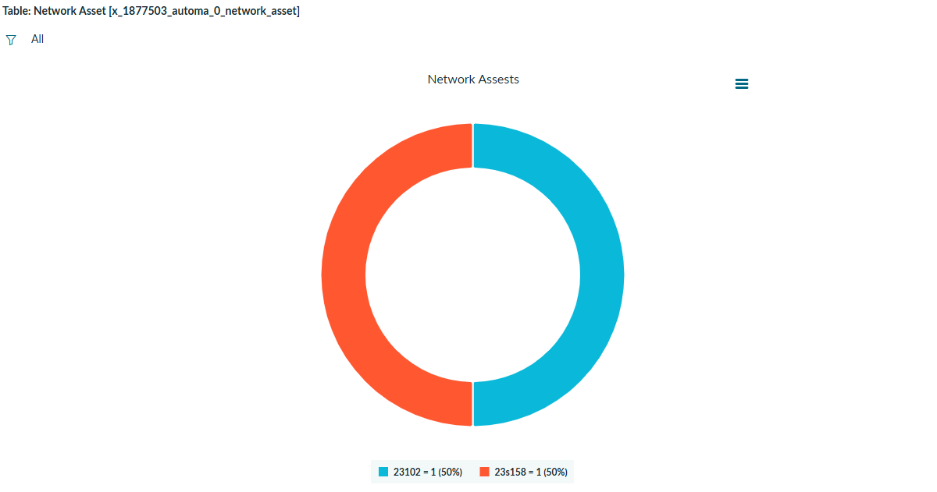

Learning Outcomes
• Created notifications.
• Verified email processing.
• Configured list layouts.
• Developed reports.

Final Testing Checklist
✓ Scoped Application
✓ Network Request Table
✓ Network Asset Table
✓ Modules
✓ UI Policy
✓ ACL
✓ Custom Role
✓ Business Rules
✓ Email Notifications
✓ Reports
✓ AI Component
✓ End-to-End Testing
✓ Application Export

Conclusion
The Automated Network Request Management (ANRM) application successfully automates the lifecycle of network service requests using the ServiceNow platform. The project demonstrates CSA and CAD concepts including scoped application development, custom tables, business rules, access controls, notifications, reporting, and AI-assisted request querying. The solution improves operational efficiency, enhances security through role-based access, and provides better visibility into network request processing.

Future Enhancements
• Multi-level approvals.
• Network asset inventory dashboard.
• SLA tracking.
• Integration with CMDB.
• Service Portal interface.
• Now Assist integration.
• Mobile application support.
• Advanced analytics dashboard.
• API integration with network monitoring tools.

